# OOP – Multimedia Shop

The goal of this lab is to practice **Object-oriented programming** by building a Multimedia Shop System for managing different items – movies, books and games. The items can be **sold** or **rented**.

## Shop Engine

Now that we have our items, rents and sales, it's time to write our **ShopEngine**. The engine will receive commands from the console and execute them. The possible commands are:

First, let's define what our engine will do:

* Supplying the store with a given quantity of items
* Selling an item in supply
* Renting an item in supply
* Reporting sales/rents

The following commands should be supported:

* **supply [type] [quantity] [params]** – adds **[quantity]** items of **[type]** to the supplies. **[params]** is a string in the format **key1=value1&key2=value2&key3=value3**, where key-value pairs are separated by **&**.
* **sell [id] [saleDate]** – sells an item with the specified **[Id]** on **[saleDate]**.
* **rent [id] [rentDate] [deadline]** – rents an item with the specified **[id]**, **[rentDate]** and **[deadline]**.
* **report sales [startDate]** – prints the sum of all sales going back to **[startDate]**.
* **report rents** – prints all **overdue rents**, ordered by their **rent fine** in ascending order (then by **title** as secondary criteria).

### Step 1 – Supplying Books

Let's implement supplying books.

We need to keep the current item supplies somewhere – in some data structure. Define a **Dictionary<key, value>** where the **key** is the item in stock (**accessed through its interface**), and **value** is the quantity. Will this dictionary be used outside ShopEngine? What access level should it have?

We also need to create some sort of loop that **reads input on each iteration** and executes the read **command**. Create a method **Run()** in our **ShopEngine** – when that method is called, an infinite loop should start reading input commands.

|  |
| --- |
| **public void Run()**  **{**  **while (true)**  **{**  **string command = Console.ReadLine();**  **// TODO: Execute command**  **}**  **}** |

Suppose we have the following input line:

* supply book 5 id=4fd332&title=Boat&price=20&author=Sellinger&genre=comedy

Our engine should parse this line and add to the supplies a **Book item with Id "4fd332", title "Boat", price 20.00, author "sellinger" and genre "comedy"** with quantity **5**.

**Note:** Parsing the line and adding the item to the supply should be done in **separate methods**!

After executing this command, our **supplies** should look as follows:

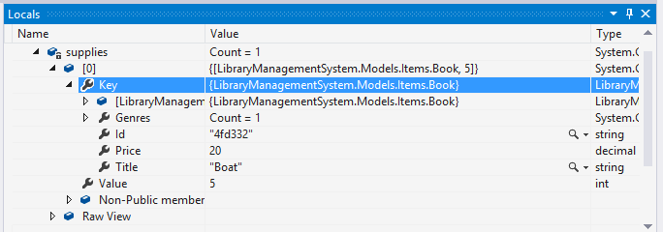

### Step 2 – Supplying Games and Videos

Implement the supply command for **games** and **videos** as well.

* supply game 4 id=sfd33&title=Assassin's_Creed&price=19.00&genre=fiction&ageRestriction=Teen
* supply video 40 id=sfd332&title=The_Godfather&price=79.00&genre=crime&legth=187

Separate different tasks into methods. Make sure you do not expose any unnecessary members outside the **ShopEngine** class.